**Experiment – 06**

**AIM**: Create a layout for multiple forms using external style sheet for styling.

**Basic Html Tags :**

* HTML**<!DOCTYPE>**Declaration: It is not an HTML tag. It is an instruction to the web browser about what version of HTML the page is written in.
* **<html>** Tag-The HTML document itself begins with <html> and ends with </html>.
* **<head>** Tag-HTML <head> tag is a Container Tag. All Header element contains like general information about page, meta-information, style sheet URL and document type information.
* **<body>** Tag-HTML body section is a main contain section of web page all contain that will be seen when the user loads the webpage.
* **<title>** Tag-The <title> tag is required in all HTML documents and it defines the title of the document.
* **<input>** Tag-The most important form element is the **<**input**>** element.The <input> element can be displayed in several ways, depending on the type attribute.
* **<label>** Tag-This element does not render as anything special for the user. However, it provides a usability improvement for mouse users, because if the user clicks on the text within the <label> element, it toggles the control.
* **<a> Tag-** It defines a hyperlink, which is used to link from one page to another.
* **<button> Tag-** The <button> tag defines a clickable button.

**Screenshots:**

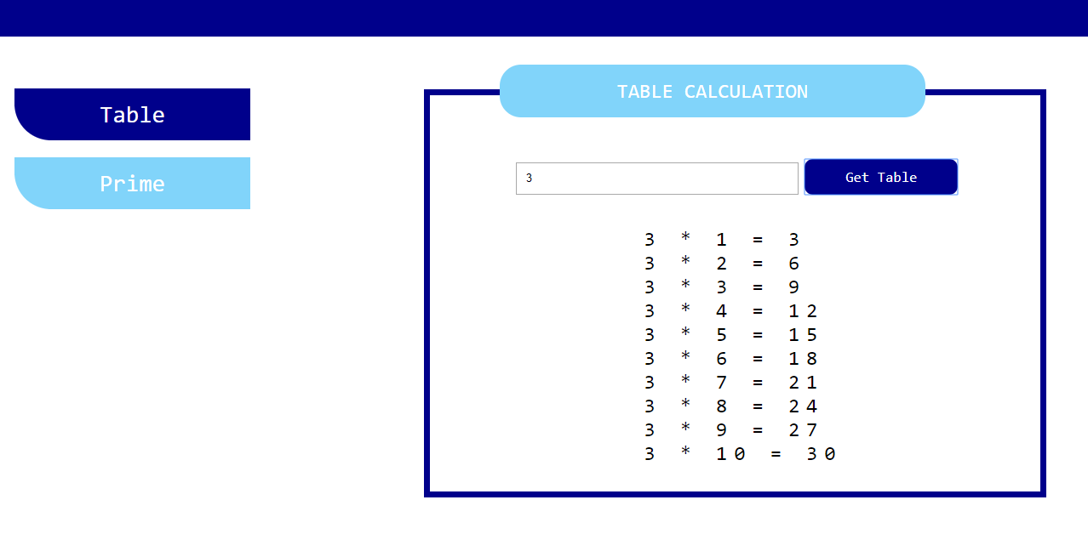

**Fig 6.1: Table Calculation**

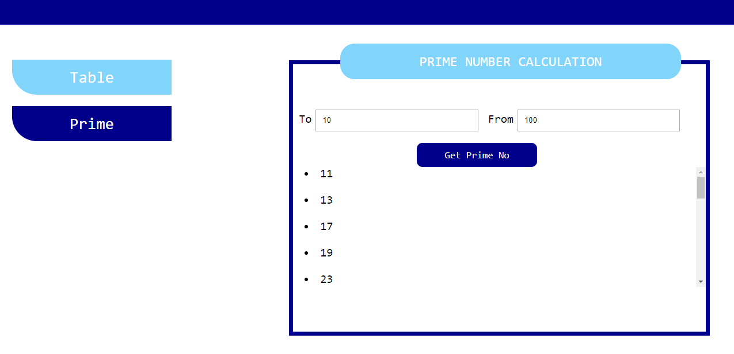

**Fig 6.2: Prime No Calculation**

**Code snippets:**

**Code for buttons :**

<div class="btn">

<button class="button" id="btn1" onclick="show_tab()" style="background: darkblue"> Table</button>

<button class="button" id="btn2" onclick="show_prime()">Prime</button>

</div>

**Code for Table Calculation:**

<div class="head">TABLE CALCULATION</div>

<div class="cal_div">

<div id="main_tab">

<input type="text" id="tab" name="table" placeholder="Enter value">

<button onclick="cal()" class="btn_tab">Get Table</button>

<div id="error_msg" class="error_msg"></div>

<div id="tab_div"></div>

</div>

**Code for Prime No Calculation:**

<div id="main_prime" style="display: none;">

<label>To</label>

<input type="text" id="to" class="input">

<label>From</label>

<input type="text" id="from" class="input">

<div id="error_mesg" class="error_msg" style="margin-left: 38px;"></div>

<button onclick="cal_prime()" class="btn_tab" style="margin-left: 30%">Get Prime No </button>

<div id="prime_div"></div>

</div></div>

**JS Code**

**Function for Table Calculation:**

function show_tab()

{

var head=document.getElementsByClassName('head');

var btn1=document.getElementById('btn1');

var btn2=document.getElementById('btn2');

var div=document.getElementById('main_tab');

var div2=document.getElementById('main_prime');

div2.style.display = "none";

div.style.display = "block";

btn1.style.background = "darkblue";

btn2.style.background = "#81D4FA";

head[0].innerHTML='TABLE CALCULATION';

}

**Function for Prime No Calculation:**

function show_prime()

{

var head=document.getElementsByClassName('head');

var btn1=document.getElementById('btn1');

var btn2=document.getElementById('btn2');

var div=document.getElementById('main_tab');

var div2=document.getElementById('main_prime');

div.style.display = "none";

div2.style.display = "block";

btn2.style.background = "darkblue";

btn1.style.background = "#81D4FA";

head[0].innerHTML='PRIME NUMBER CALCULATION';

}